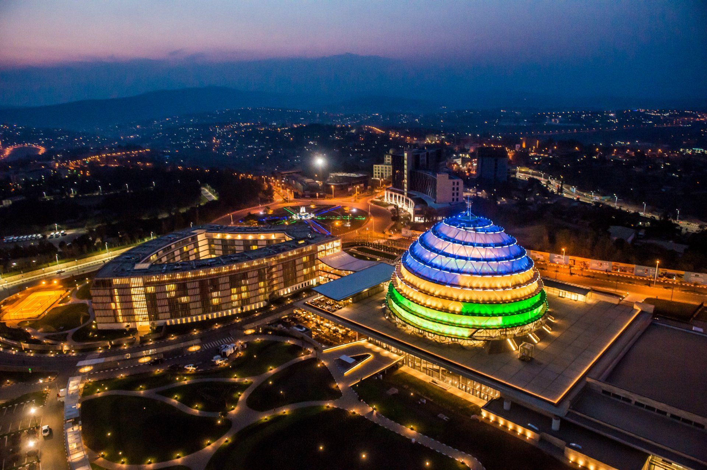FGGFGFFGHH

BY: FBDA20-046

Website Development on

KIGALI

The City Of Cleanness and Security

**INFORMATION STRUCTURE**

**Name of Website**

Kigali

**Purpose**

The website will act as an informative portal that will educate tourists and enthusiasts on the beauty of the City of Rwanda KIGALI.

The website will include of the following.

* **Home/Index Page**: It will have a brief description of what the City Holds for the user as well as what to expect as one explores the website. The page will harbour hyperlinks that redirect the user to the other pages and resources pertaining to Kigali.
* **About:** This page is to have a further elaboration on information regarding the city, it will answer the WHO, WHY, WHEN, HOW, WHERE and WHICH questions. It will include of information that explains *when the City was founded, who founded the city, who lives in the city, where is the city, how many people live in the city and how it came to be the capital city of Rwanda. The main aim is to include facts and foundations that will not bore the user but educate and entertain thus explaining why it must be* ***edutaining****.*
* **Lifestyle:** This page is more ideal to the people interested in visiting the city for relaxation or a vacation, the page is to include of content that lures the user and ignites the zeal to visit the city. It will include of tourist attraction sites, hotels, schools, recreation centres, culture/way of life of the people in Kigali. It should have graphical content that visualises the expectation for the user.
* **Events:** The programs in the city , activities set to take place in the city will be displayed here and information about those events will also be included here to enable the user to show interest.
* **Connect/Contact:** It will be the page that harbours contact information of how the user can receive notifications(weekly) on the events or activities that will be happening in the city. This page will also harbour a form with the following details: 1. Full names, Country and Region and Email. After the forms has been filled the user will be redirected to the Acknowledgement of Subscription page (Thank You.Html).

**SITE MAP**

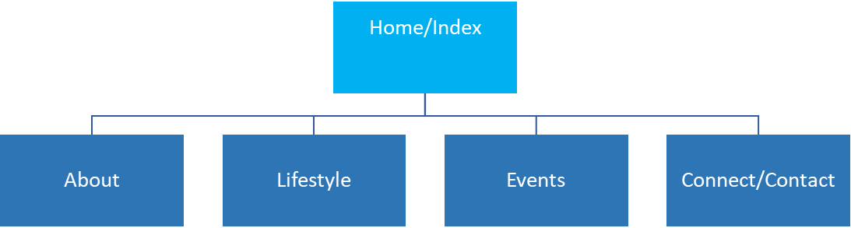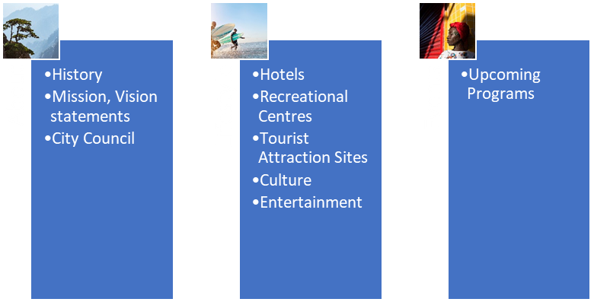

Connect

Subscribe To Newsletter

**Website Framework**

**PAGE TEMPLATES**

